**Experiment 8**

**AWS S3**

1. **Create a bucket, add an object to the bucket and delete the bucket. Make the object publicly accessible**

**Step-1:** Login to your AWS console page and search for S3. Click on create bucket.

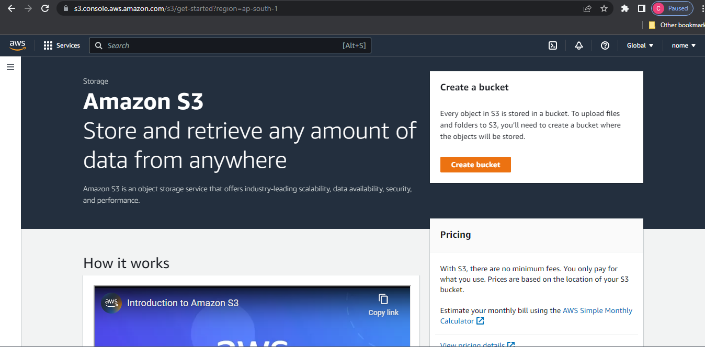

**Step-2:** Add name to your S3 bucket.

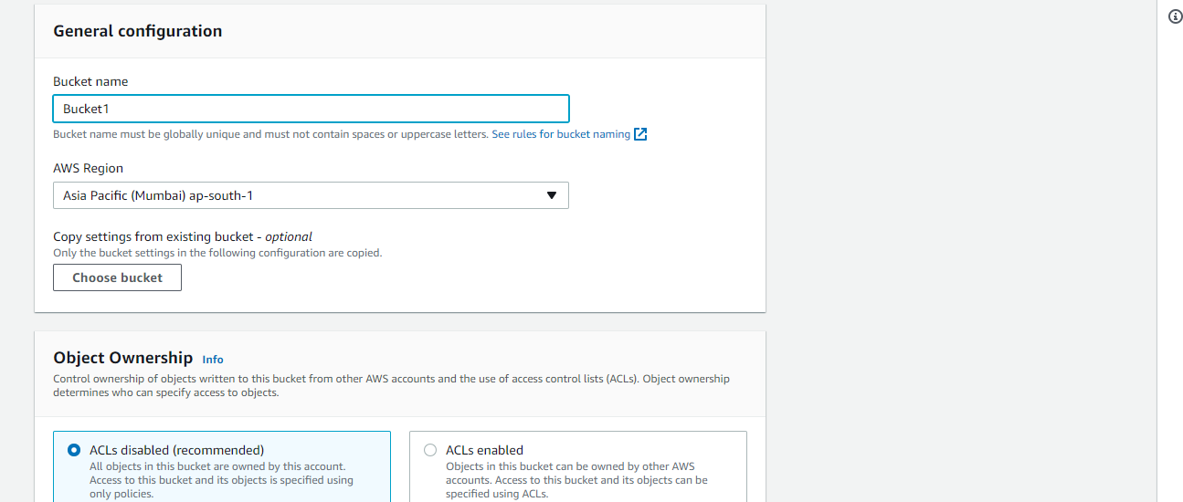

**Step 3:** Don’t change the object ownership settings. Set them as the default ones only.

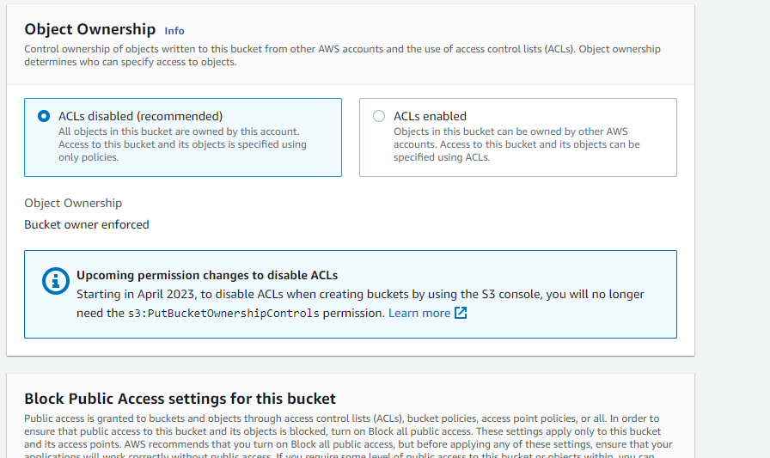

**Step-4:** Uncheck the ‘Block all public access’ to make the object publicly accessible.

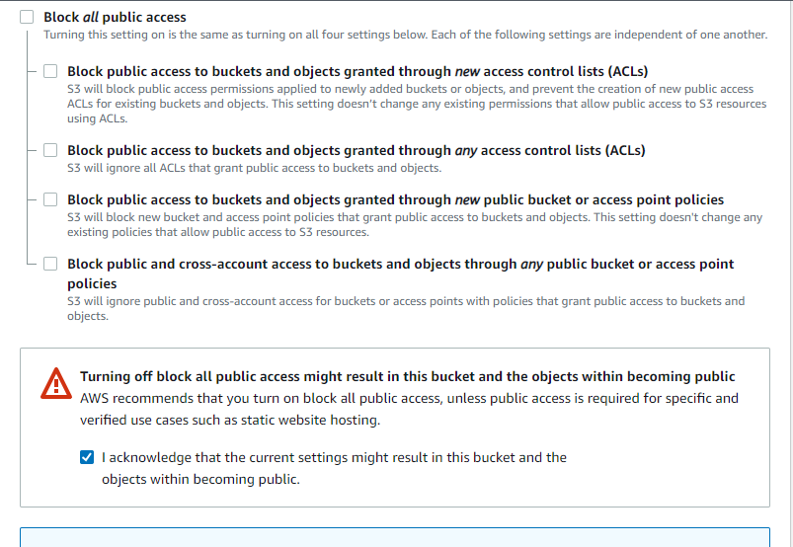

**Step-5:** Disable the bucket versioning

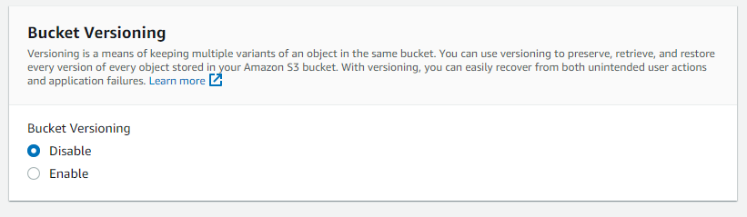

**Step-6:** Set the default encryption and disable the object lock and proceed to create bucket.

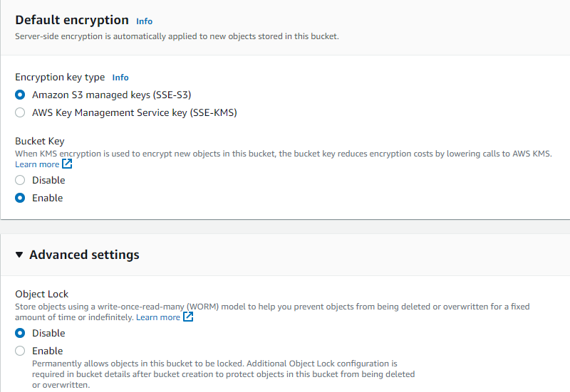

**Step-7:** Bucket has been successfully created.

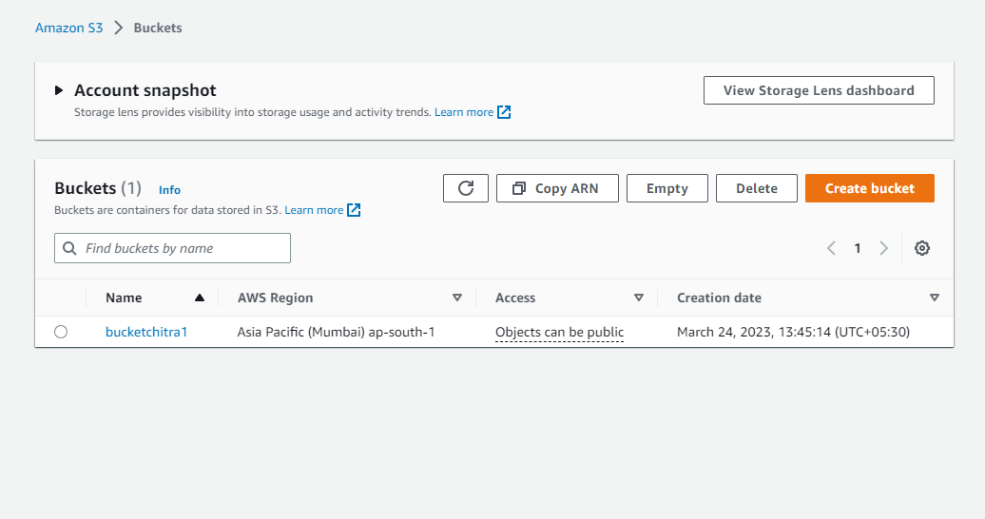

**Step-8:** Click on the bucket and upload file.

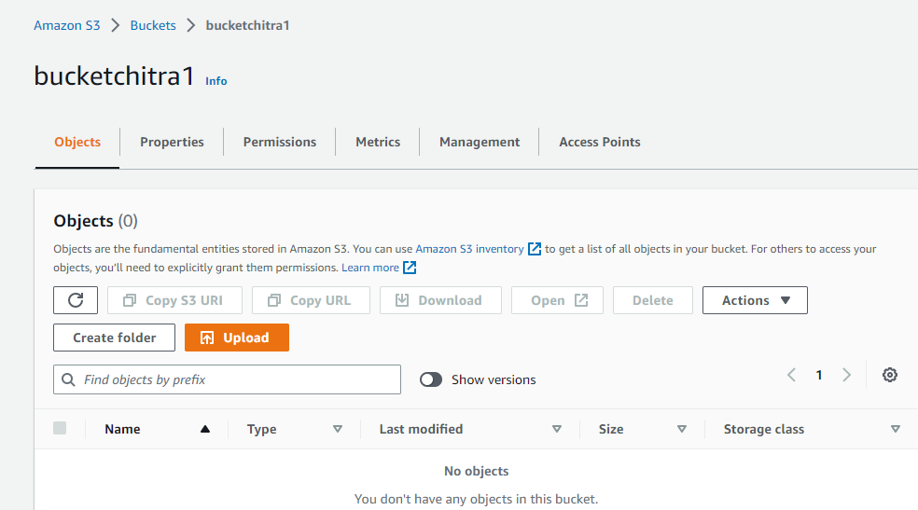

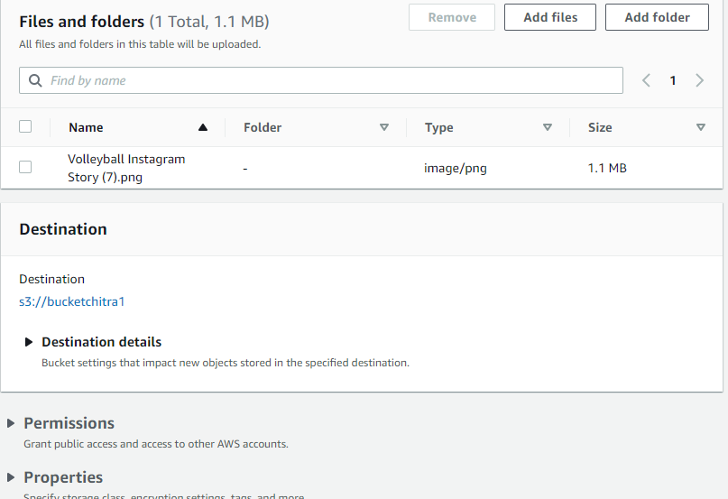

**Step-9:** Now click on permissions tab.

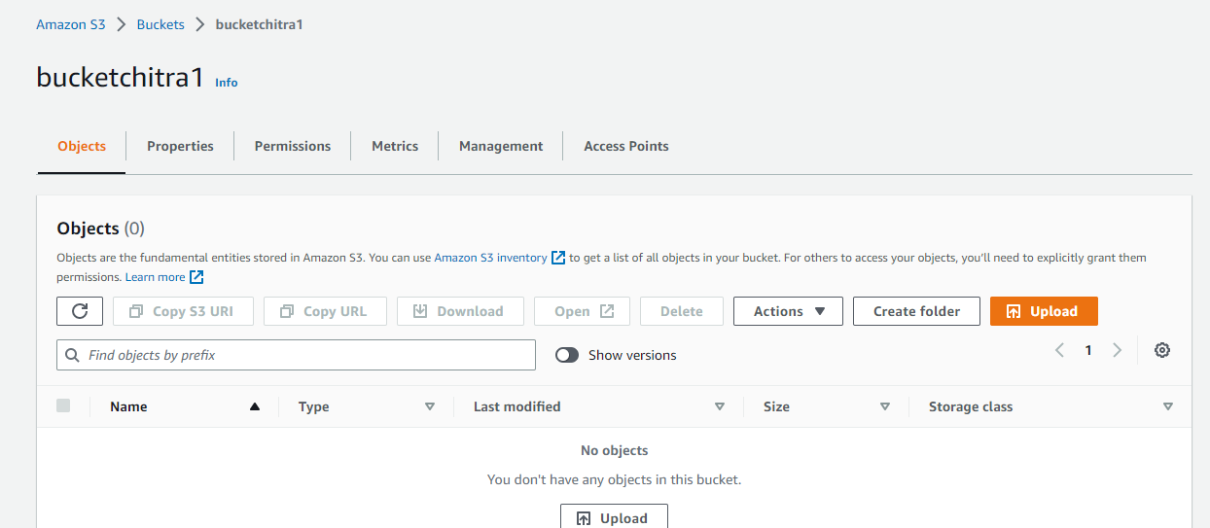

**Step-10:** Now click on edit and upload the policy for S3 bucket.

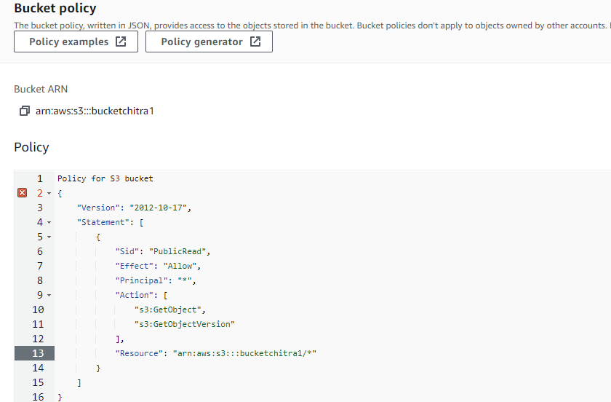

**Step-11:** Now copy the url of the file and open it in incognito tab.

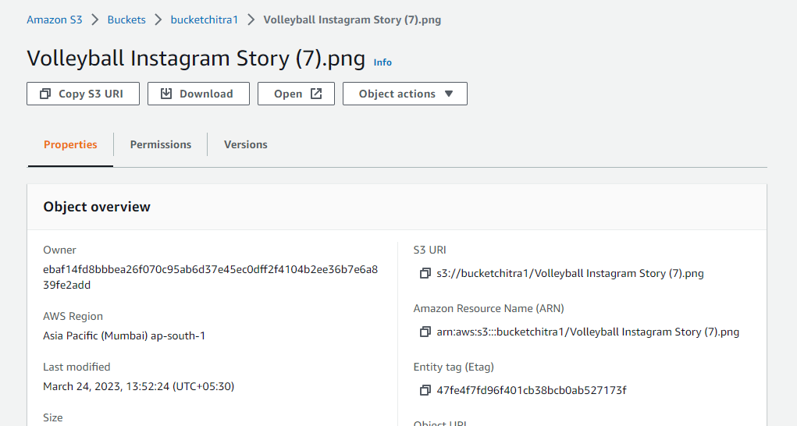

**Step-12:** Here we can see that the file is successfully opened in the incognito tab and it is publicly accessible

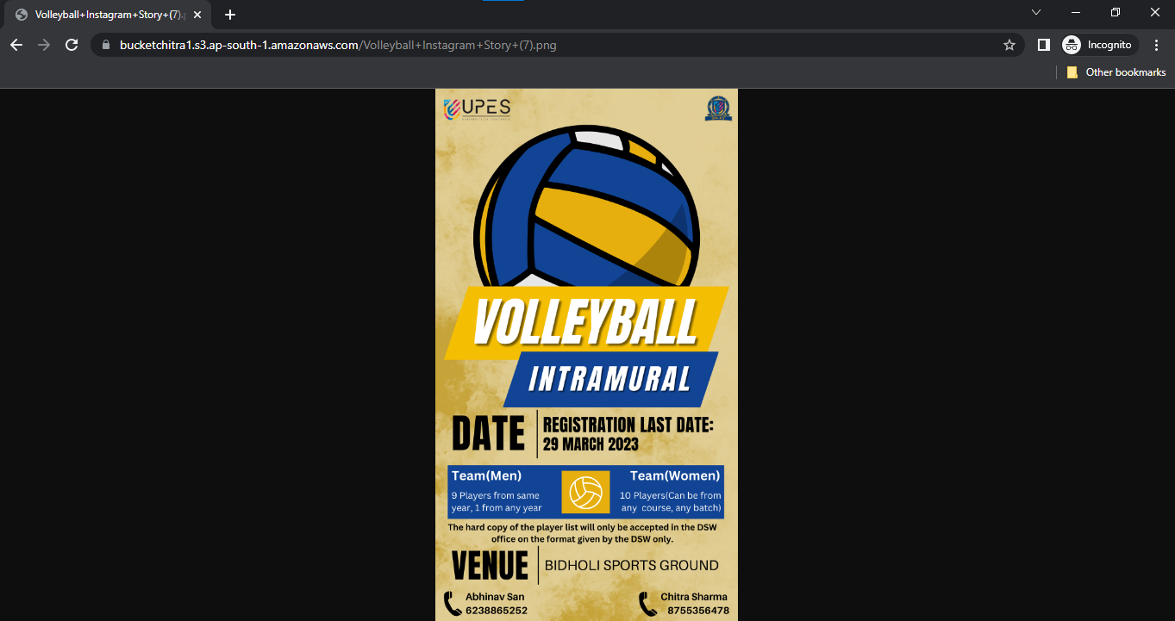

**Step-13:** To delete the bucket we need to clear the bucket first. So, chose the objects of the bucket and click on delete tab.

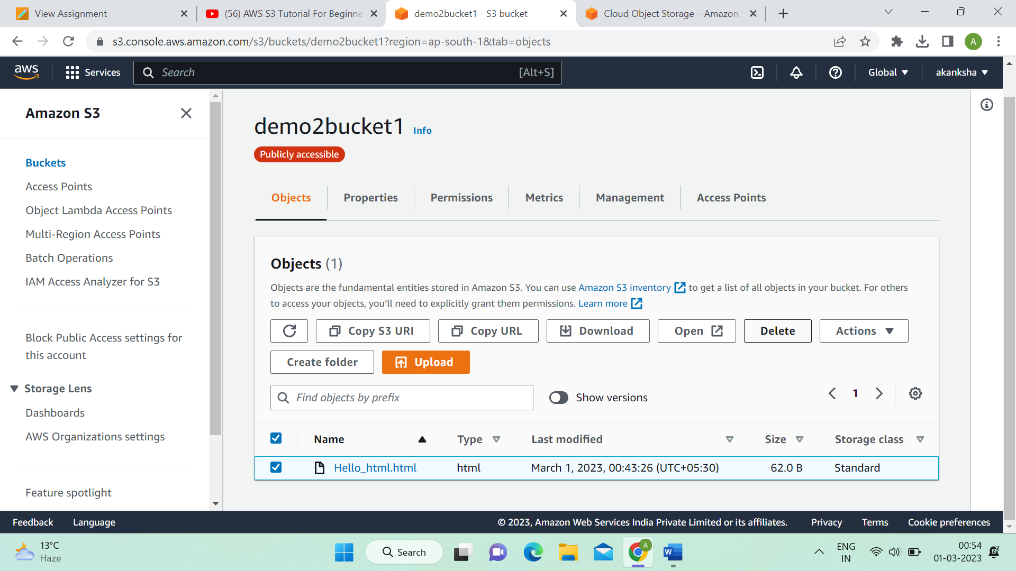

**Step 14**: Write delete word in input field.

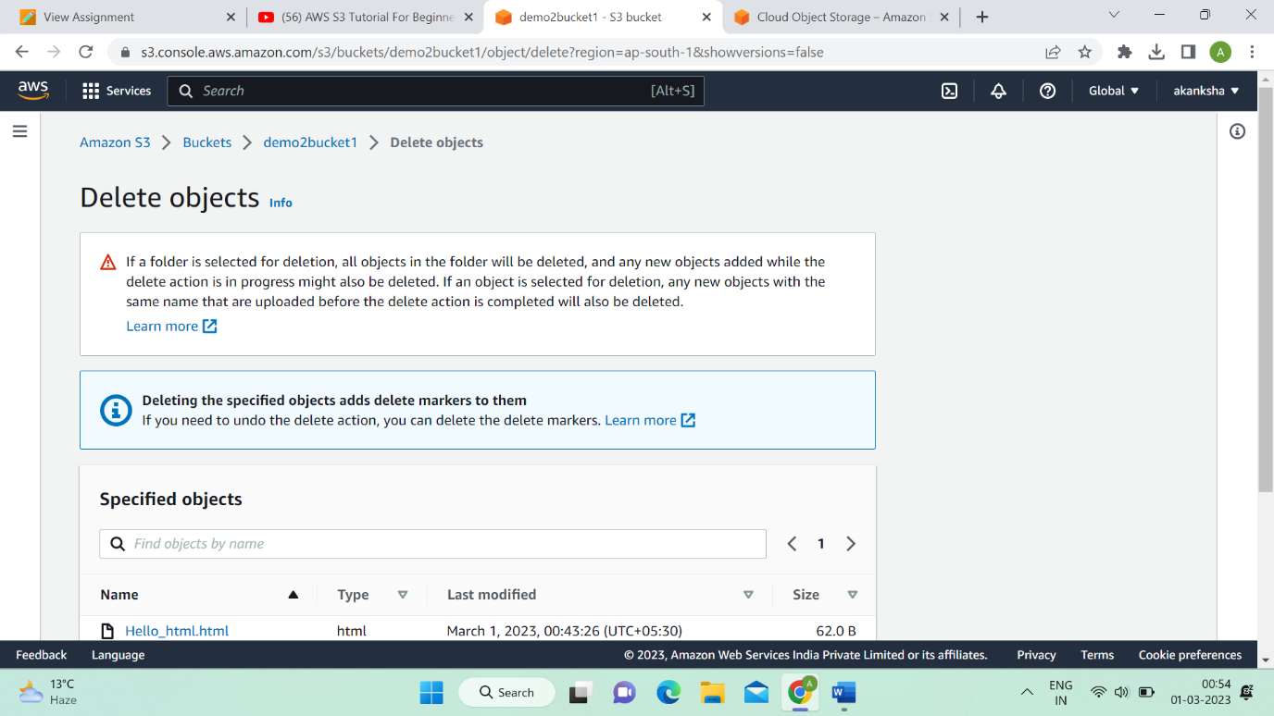

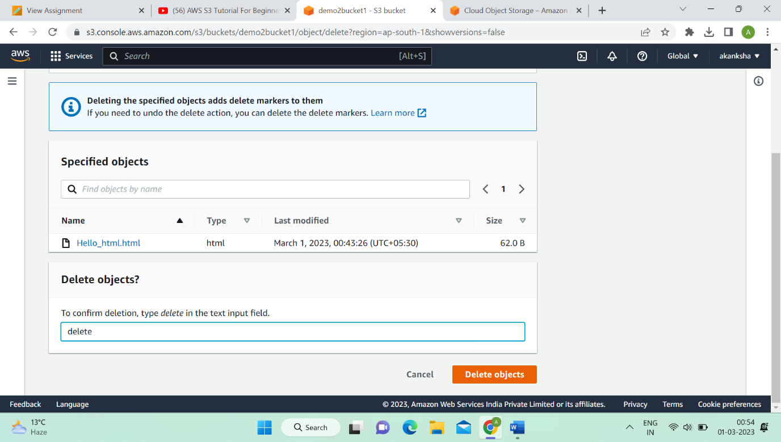

**Step 15:** Select bucket and click on delete option.

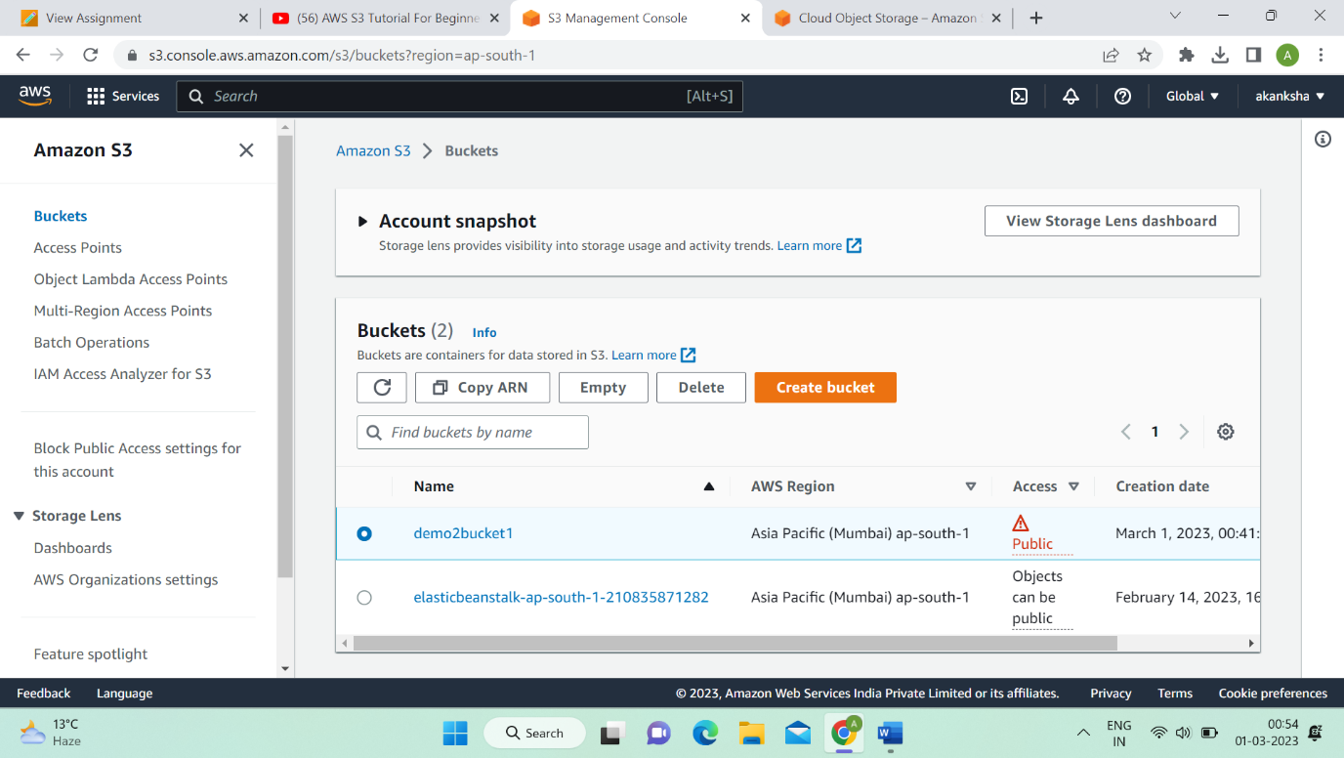

**Step 16:** Write permanently delete words in input field and click on empty option.

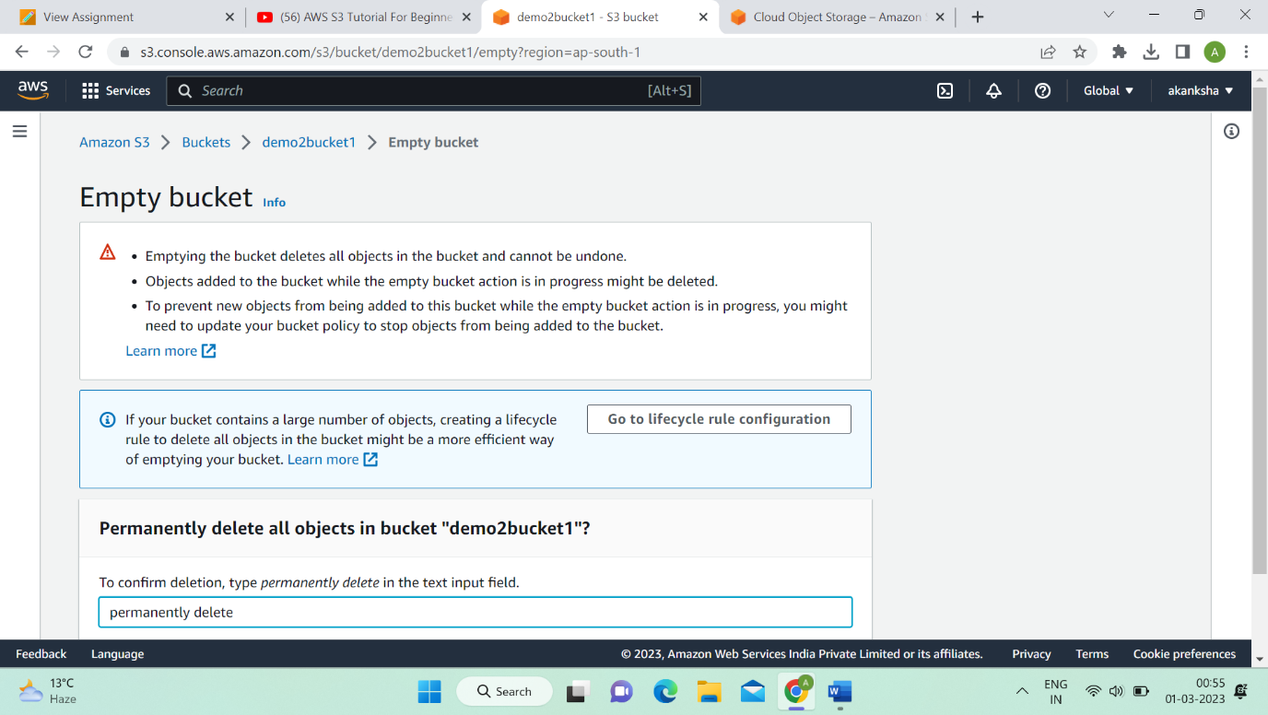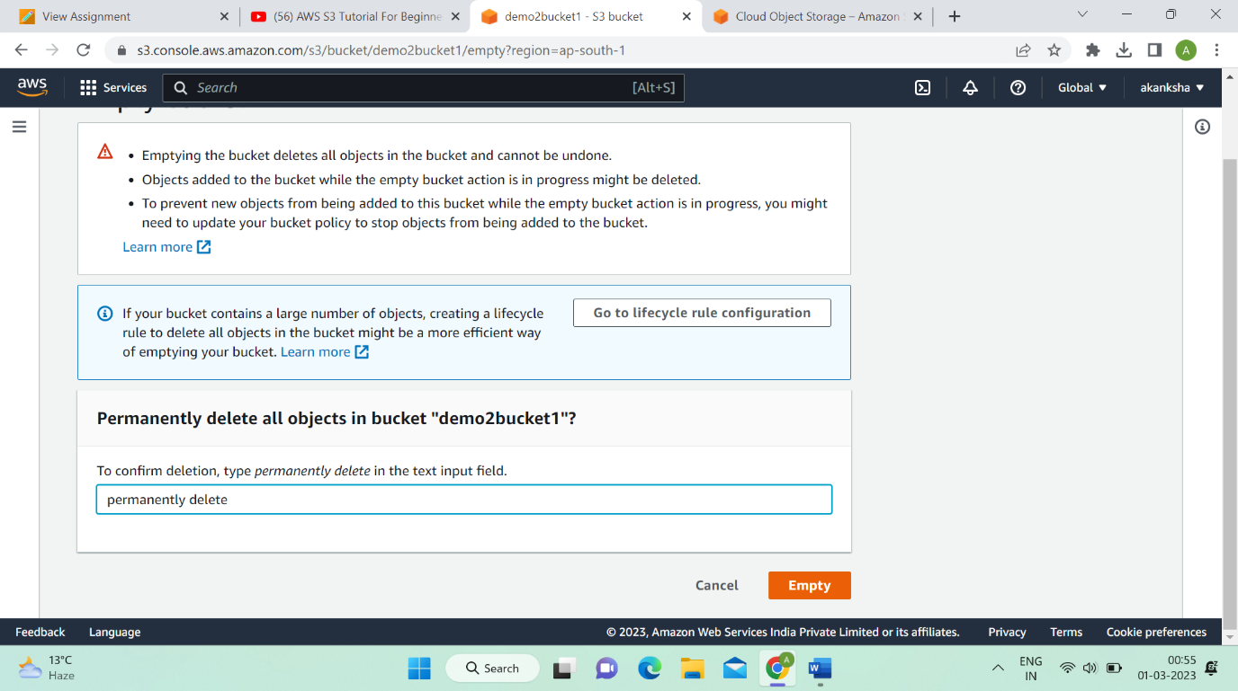

1. **Host a static website on S3**

**Step-1:** Now go to the bucket and upload an html file or any other file that you want to host.

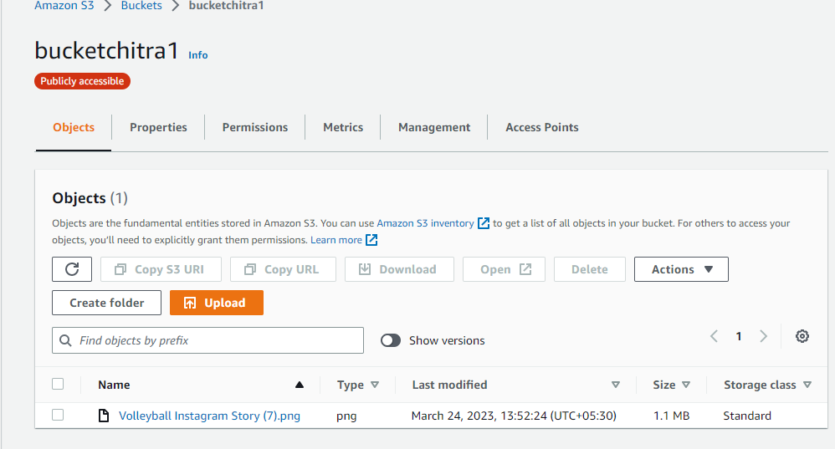

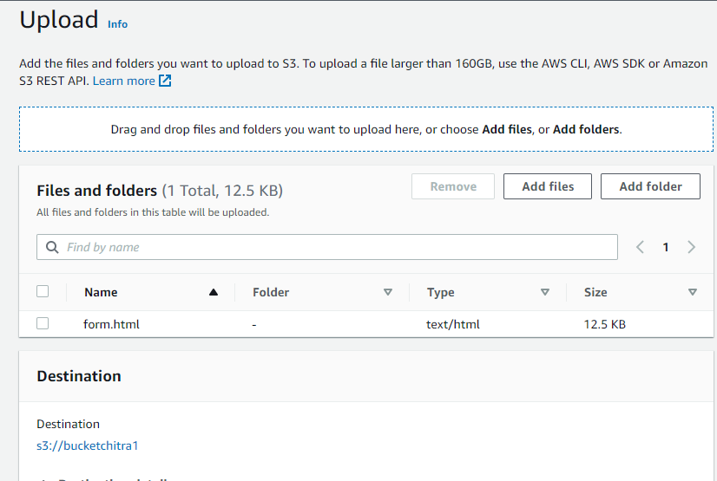

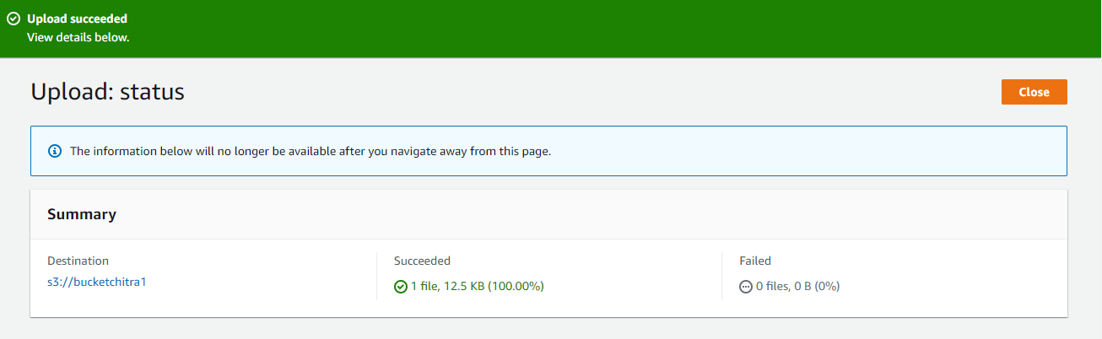

**Step-2:** Now enable the static website hosting and update the hosting type.

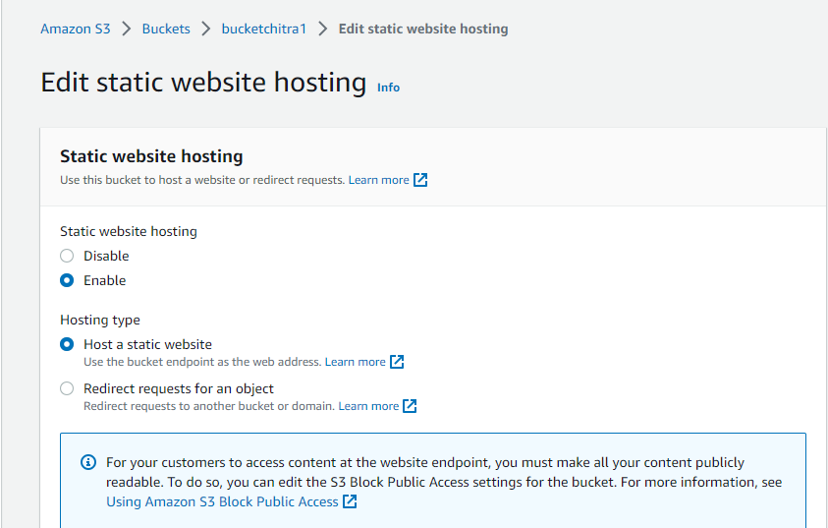

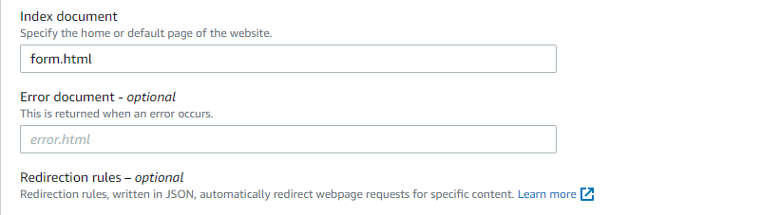

**Step-3:** Now copy the url of the html file and open it in incognito tab. It is successfully opened.

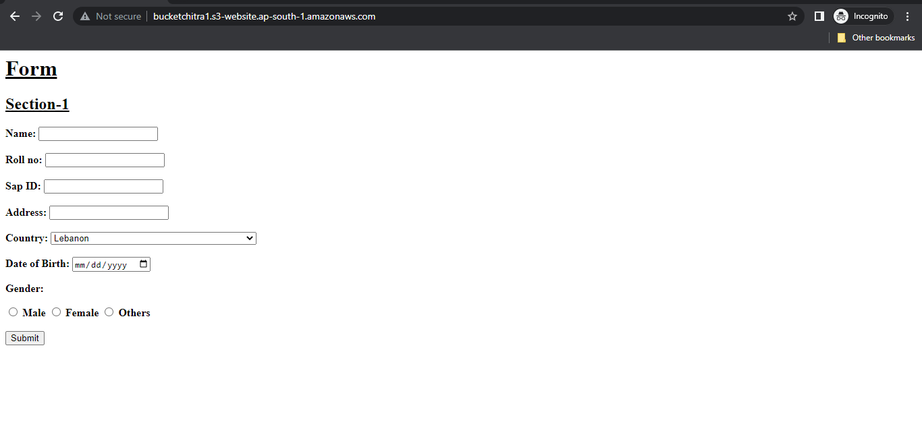

**QUESTIONS**

**Ques 1:** Differentiate between EBS, EFS and S3 storage?

**Ans:** Amazon Web Services (AWS) provides several different storage options for users, including Elastic Block Store (EBS), Elastic File System (EFS), and Simple Storage Service (S3). Here are the differences between them:

**Elastic Block Store (EBS):** EBS provides block-level storage volumes for use with Amazon EC2 instances. EBS volumes are like virtual hard drives that can be attached to EC2 instances, and they provide persistent storage that can survive even if the EC2 instance is terminated. EBS is best suited for situations where you need to store data that is frequently accessed and requires low latency.

**Elastic File System (EFS):** EFS provides a scalable file system for use with EC2 instances. EFS is a fully managed service that can be accessed from multiple EC2 instances concurrently, making it well suited for use cases such as content repositories, big data analytics, and media processing workflows. EFS is a shared file system, which means that multiple EC2 instances can access the same data at the same time. It is best suited for situations where you need to store large amounts of data that is accessed by multiple EC2 instances.

**Simple Storage Service (S3):** S3 is a highly scalable, secure, and durable object storage service that can be used to store and retrieve any amount of data from anywhere on the web. S3 is designed for large-scale storage of unstructured data, such as photos, videos, and log files. It provides high durability, meaning that your data is protected against hardware failure, and it also provides high availability, meaning that your data is accessible from anywhere at any time.

**Ques 2:** List the features of S3 storage?

**Ans:** Amazon S3 (Simple Storage Service) is an object storage service provided by Amazon Web Services (AWS). Here are some of the key features of S3:

**1.Scalability**: S3 can store and retrieve any amount of data, and can scale to accommodate a virtually unlimited number of objects.

**2.Durability:** S3 is designed for 99.999999999% durability, meaning that it is highly unlikely for data to be lost.

**3.Availability**: S3 provides high availability and can be accessed from anywhere in the world using an internet connection.

**4.Security**: S3 supports encryption at rest and in transit, and allows users to configure access control policies to restrict access to their data.

**5.Lifecycle policies:** S3 allows users to create lifecycle policies to automatically transition data to different storage classes or delete it when it is no longer needed.

**6.Versioning:** S3 supports versioning, which enables users to store multiple versions of an object and retrieve previous versions if needed.

**7.Performance**: S3 provides high throughput and low latency performance for both uploading and downloading objects.

**8.Cost-effective**: S3 offers flexible pricing options, including pay-as-you-go pricing, and can help users reduce storage costs by automatically moving data to lower-cost storage classes based on their usage patterns.

**9.Integration with other AWS services**: S3 can be integrated with other AWS services, such as Amazon Glacier, Amazon CloudFront, and AWS Lambda, to build powerful, scalable applications.

**Ques 3:** What are the different types of storage classes available in S3?

**Ans:** Amazon S3 offers several storage classes, each with different performance, durability, and cost characteristics. The different types of storage classes available in S3 are:

**1.S3 Standard:** This is the default storage class and is designed for frequently accessed data. It offers high durability, availability, and performance.

**2.S3 Intelligent-Tiering:** This storage class is designed to optimize costs by automatically moving data between two access tiers based on changing access patterns. It is best suited for data with unknown or changing access patterns.

**3.S3 Standard-Infrequent Access (S3 Standard-IA):** This storage class is designed for long-lived, infrequently accessed data. It offers high durability and availability, but with lower storage costs than S3 Standard.

**4.S3 One Zone-Infrequent Access (S3 One Zone-IA): This** storage class is like S3 Standard-IA but is designed for data that can be recreated if lost. It is stored in a single availability zone, which makes it less durable than other storage classes.

**5.S3 Glacier:** This storage class is designed for data archiving and long-term backup. It offers the lowest storage costs but with longer retrieval times.

**6.S3 Glacier Deep Archive:** This storage class is designed for long-term data archiving with retrieval times of 12 hours or more. It offers the lowest storage costs of any S3 storage class. **7.S3 Outposts:** This storage class is designed for applications that require S3 storage on-premises. It enables users to store and access S3 objects using the same S3 API and management tools they use in the cloud.

**Ques 4:** Explain the lifecycle management in S3 and different action associated with it.

**Ans:** S3 Lifecycle management is a feature that allows you to define rules to automatically transition objects to different storage classes or delete them when they are no longer needed. This can help you optimize costs and performance by moving data to the most appropriate storage class based on its lifecycle. The following are the different actions associated with S3 lifecycle management:

**1.Transition actions:** These actions are used to move objects to different storage classes as they age. For example, you can configure a rule to transition objects from the S3 Standard storage class to the S3 Intelligent-Tiering storage class after 30 days, or to the S3 Glacier storage class after 60 days.

**2.Expiration actions:** These actions are used to delete objects when they are no longer needed. For example, you can configure a rule to delete objects after they have been in the S3 Glacier storage class for 180 days.

**3.Intelligent-Tiering actions:** These actions are used to optimize storage costs and performance by automatically moving objects between the two access tiers (frequent and infrequent) based on changing access patterns.

**4.S3 Glacier Deep Archive actions:** These actions are used to move objects to the S3 Glacier Deep Archive storage class, which is designed for long-term archival of data that is accessed once or twice a year.

To use S3 Lifecycle management, you create a lifecycle configuration, which is a set of rules that define the actions to be taken on objects in your bucket. You can apply the lifecycle configuration to the entire bucket or to a specific prefix within the bucket. Once the configuration is in place, S3 will automatically apply the rules to the objects in your bucket based on their age or other criteria specified in the rules. This helps you save time and effort, and ensure that your data is stored in the most cost-effective and efficient way possible.